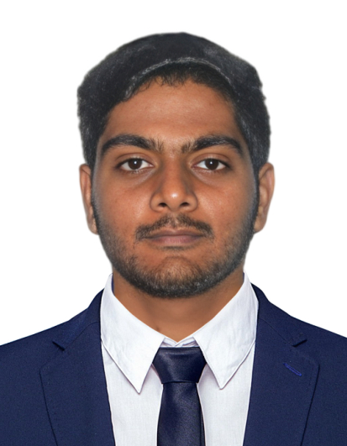 |  | Ramalingam k  Customer Support Executive
Profile  Customer-focused support professional with strong interpersonal skills and a proven ability to build lasting relationships with customers. Skilled in active listening and empathy, able to understand and anticipate customer needs and provide effective solutions. Organized and dependable candidate successful at managing multiple priorities with a positive attitude. Willingness to take on added responsibilities to meet team goals.  Contact  PHONE:  9788551732  EMAIL:  k.ramu196@gmail.com  Hobbies & INTEREST  Playing Badminton  Collecting Stamp  Cycle Riding  Reading Historical Books  Travelling |  | EDUCATION  The New College  2016 – 2018  MA English Literature  Completed with 62%  Jamal Mohamed College  2014 - 2016  BA English Literature  Completed with 57%  WORK EXPERIENCE  HDFC Life, Sales Development Manager  March 2021–April 2022  Meeting the prospective customers with channel sales team to sell insurance solutions Ensuring quality of business and Persistency.  Overall, the Front-Line Sales (FLS) need to ensure to Engage Channel Partners, Strive for Customer Satisfaction and Achieve Sales Targets within the deadline.  Omega Healthcare, Accounts Receivable – Caller  June 2022 – Sep 2022  Worked in call center environment handling manual and automatically dialed outbound calls. Prior experience of working in a medical billing company and use of medical billing software.  Knowledge of Healthcare terminology and CPT codes.  I worked in Exact part of Eligibility Verification.  Skills  - Customer Advising and Referral  - Communication in both Vocal and Written  - Flexible to work in Team Environment  - Customer Account Review  - Process Payments  - Proofreading  - CRM Software  - Microsoft Office

